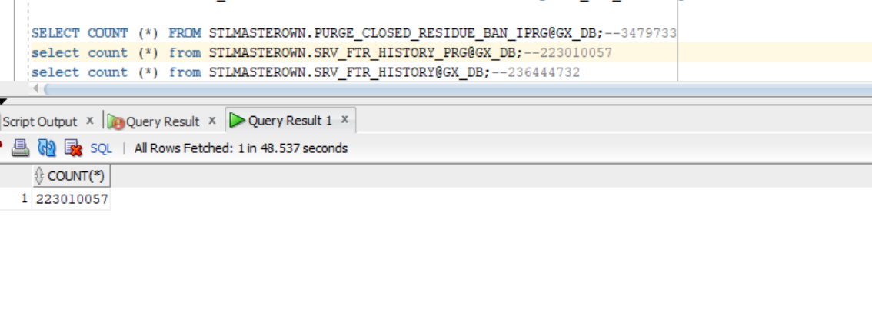

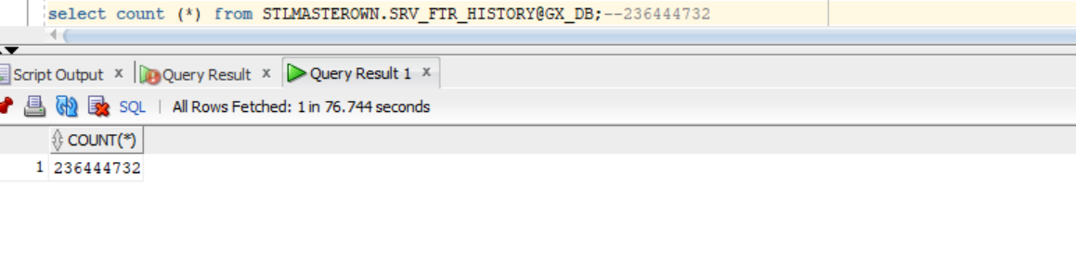

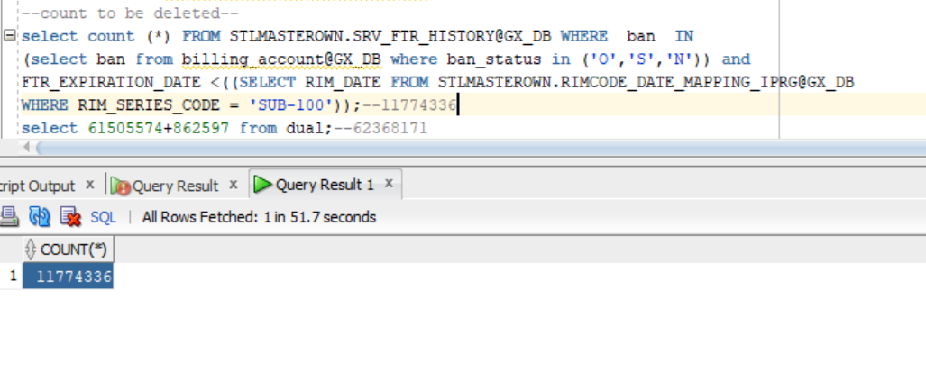

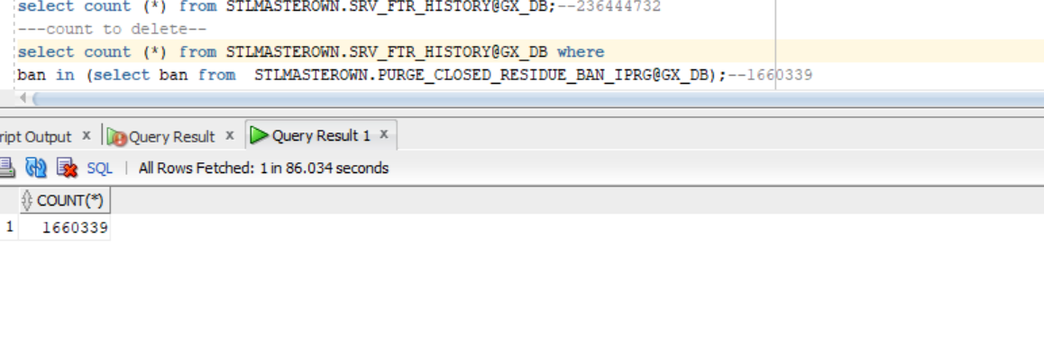

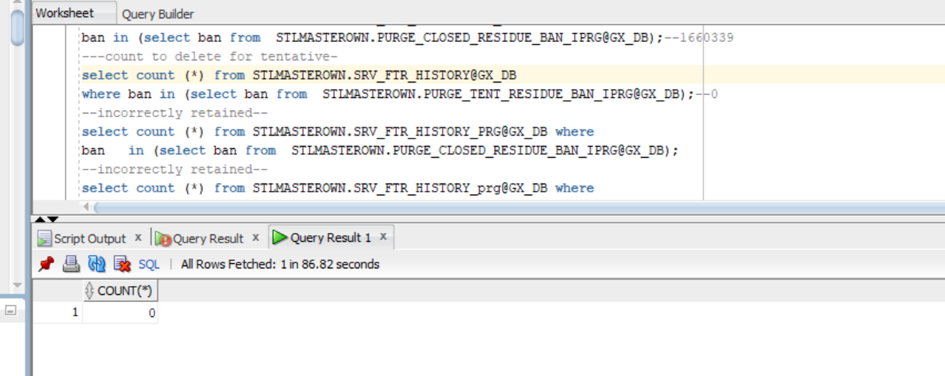

Matching with prg

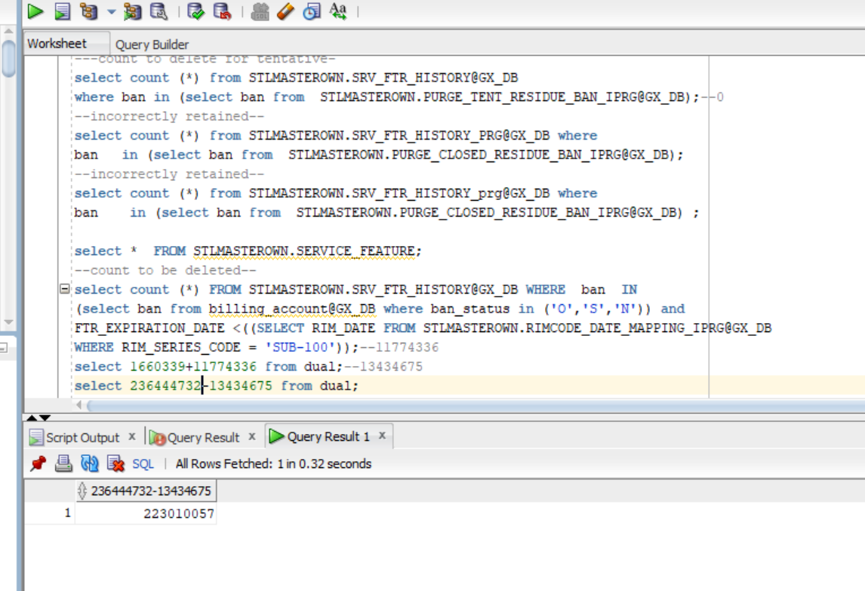

create database link GX_DB connect to STLMASTERCON identified by DEC_RIC_22 using 'GXSTLC1';

SELECT COUNT (*) FROM STLMASTEROWN.PURGE_CLOSED_RESIDUE_BAN_IPRG@GX_DB;--3479733

select count (*) from STLMASTEROWN.SRV_FTR_HISTORY_PRG@GX_DB;--223010057

select count (*) from STLMASTEROWN.SRV_FTR_HISTORY@GX_DB;--236444732

---count to delete--

select count (*) from STLMASTEROWN.SRV_FTR_HISTORY@GX_DB where

ban in (select ban from STLMASTEROWN.PURGE_CLOSED_RESIDUE_BAN_IPRG@GX_DB);--1660339

---count to delete for tentative-

select count (*) from STLMASTEROWN.SRV_FTR_HISTORY@GX_DB

where ban in (select ban from STLMASTEROWN.PURGE_TENT_RESIDUE_BAN_IPRG@GX_DB);--0

--incorrectly retained--

select count (*) from STLMASTEROWN.SRV_FTR_HISTORY_PRG@GX_DB where

ban in (select ban from STLMASTEROWN.PURGE_CLOSED_RESIDUE_BAN_IPRG@GX_DB);

--incorrectly retained--

select count (*) from STLMASTEROWN.SRV_FTR_HISTORY_prg@GX_DB where

ban in (select ban from STLMASTEROWN.PURGE_CLOSED_RESIDUE_BAN_IPRG@GX_DB) ;

select * FROM STLMASTEROWN.SERVICE_FEATURE;

--count to be deleted--

select count (*) FROM STLMASTEROWN.SRV_FTR_HISTORY@GX_DB WHERE ban IN

(select ban from billing_account@GX_DB where ban_status in ('O','S','N')) and

FTR_EXPIRATION_DATE <((SELECT RIM_DATE FROM STLMASTEROWN.RIMCODE_DATE_MAPPING_IPRG@GX_DB

WHERE RIM_SERIES_CODE = 'SUB-100'));--11774336

select 1660339+11774336 from dual;--13434675

select 236444732-13434675 from dual;

--count to incorrectly retained--

select count (*) FROM STLMASTEROWN.ADDRESS_NAME_LINK_PRGWHERE ban IN (select ban from billing_account where ban_status

in ('O','S','N')) and EXPIRATION_DATE <((SELECT RIM_DATEFROM STLMASTEROWN.RIMCODE_DATE_MAPPING_IPRGWHERE RIM_SERIES_CODE = 'SUB-100'));

4th table

Table

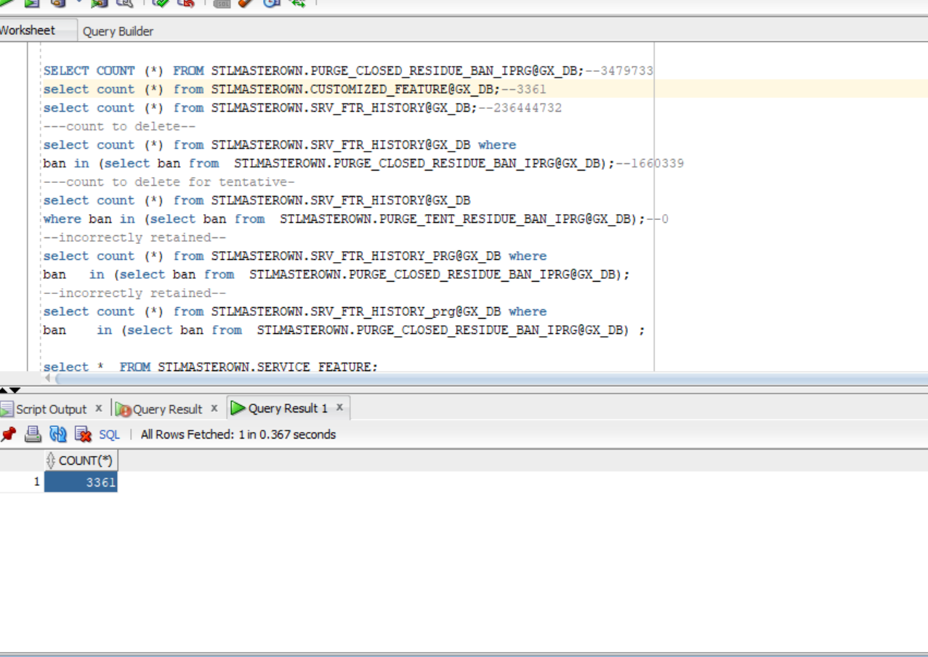

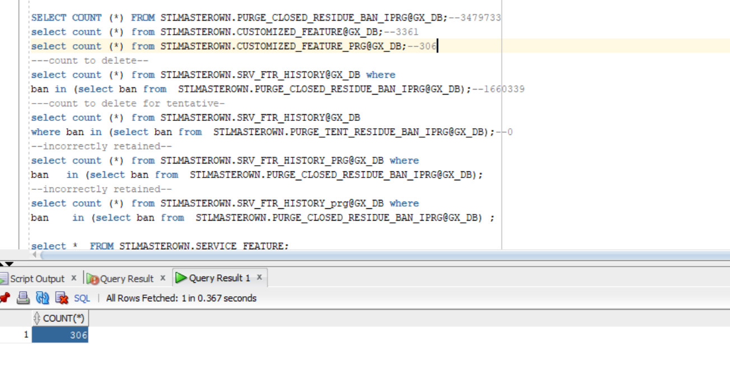

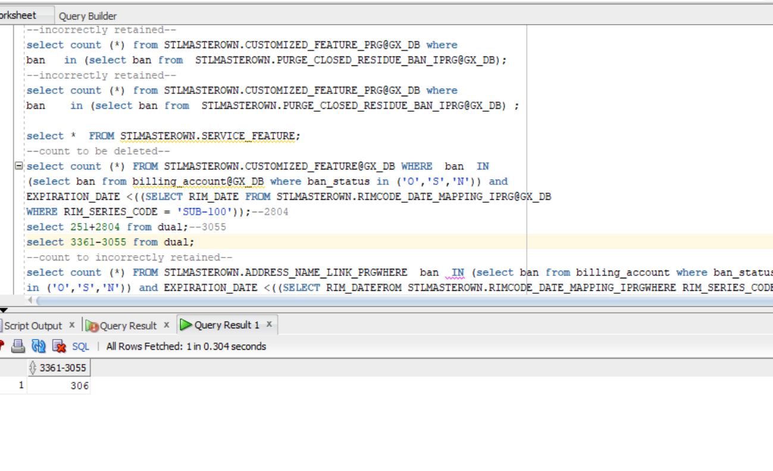

create database link GX_DB connect to STLMASTERCON identified by DEC_RIC_22 using 'GXSTLC1';

SELECT COUNT (*) FROM STLMASTEROWN.PURGE_CLOSED_RESIDUE_BAN_IPRG@GX_DB;--3479733

select count (*) from STLMASTEROWN.CUSTOMIZED_FEATURE@GX_DB;--3361

select count (*) from STLMASTEROWN.CUSTOMIZED_FEATURE_PRG@GX_DB;--306

---count to delete--

select count (*) from STLMASTEROWN.CUSTOMIZED_FEATURE@GX_DB where

ban in (select ban from STLMASTEROWN.PURGE_CLOSED_RESIDUE_BAN_IPRG@GX_DB);--251

---count to delete for tentative-

select count (*) from STLMASTEROWN.CUSTOMIZED_FEATURE@GX_DB

where ban in (select ban from STLMASTEROWN.PURGE_TENT_RESIDUE_BAN_IPRG@GX_DB);--0

--incorrectly retained--

select count (*) from STLMASTEROWN.CUSTOMIZED_FEATURE_PRG@GX_DB where

ban in (select ban from STLMASTEROWN.PURGE_CLOSED_RESIDUE_BAN_IPRG@GX_DB);

--incorrectly retained--

select count (*) from STLMASTEROWN.CUSTOMIZED_FEATURE_PRG@GX_DB where

ban in (select ban from STLMASTEROWN.PURGE_CLOSED_RESIDUE_BAN_IPRG@GX_DB) ;

select * FROM STLMASTEROWN.SERVICE_FEATURE;

--count to be deleted--

select count (*) FROM STLMASTEROWN.CUSTOMIZED_FEATURE@GX_DB WHERE ban IN

(select ban from billing_account@GX_DB where ban_status in ('O','S','N')) and

EXPIRATION_DATE <((SELECT RIM_DATE FROM STLMASTEROWN.RIMCODE_DATE_MAPPING_IPRG@GX_DB

WHERE RIM_SERIES_CODE = 'SUB-100'));--2804

select 251+2804 from dual;--3055

select 3361-3055 from dual;

5th table

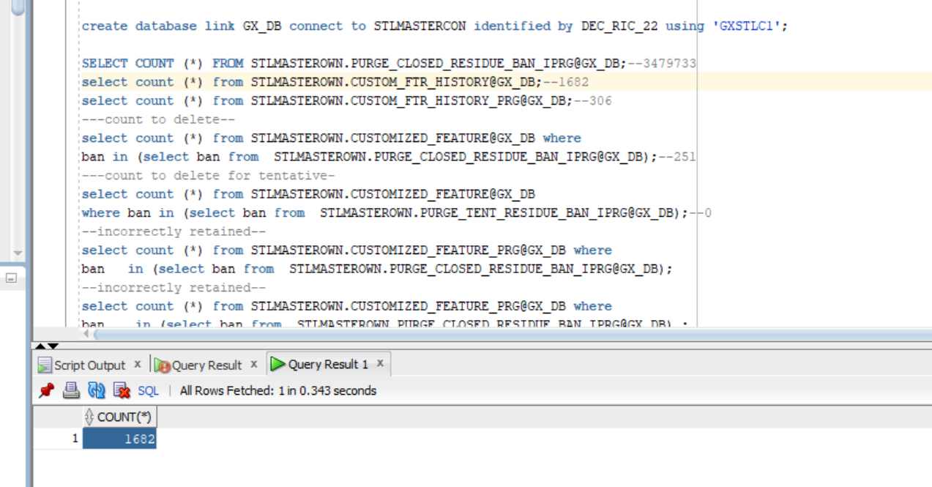

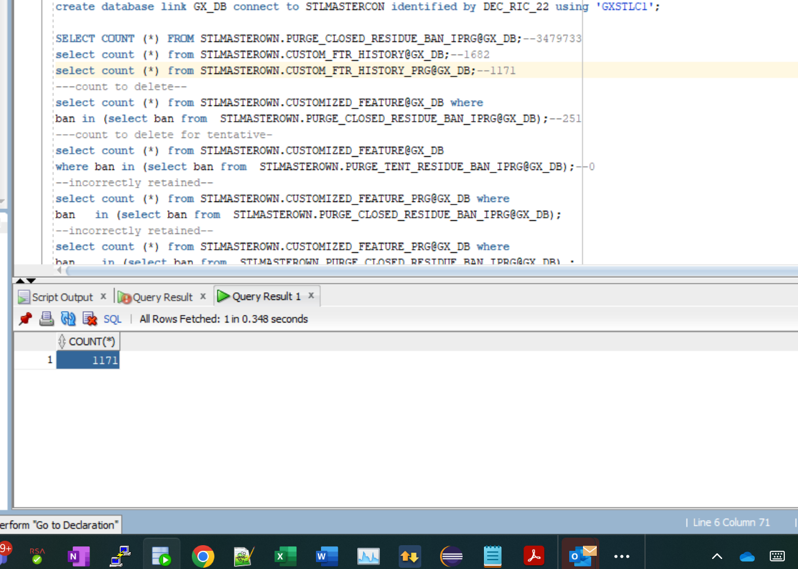

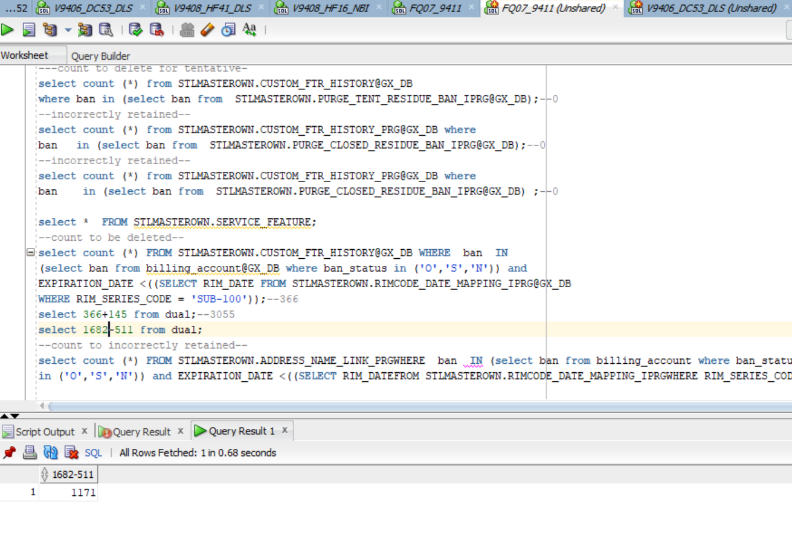

create database link GX_DB connect to STLMASTERCON identified by DEC_RIC_22 using 'GXSTLC1';

SELECT COUNT (*) FROM STLMASTEROWN.PURGE_CLOSED_RESIDUE_BAN_IPRG@GX_DB;--3479733

select count (*) from STLMASTEROWN.CUSTOM_FTR_HISTORY@GX_DB;--1682

select count (*) from STLMASTEROWN.CUSTOM_FTR_HISTORY_PRG@GX_DB;--1171

---count to delete--

select count (*) from STLMASTEROWN.CUSTOM_FTR_HISTORY@GX_DB where

ban in (select ban from STLMASTEROWN.PURGE_CLOSED_RESIDUE_BAN_IPRG@GX_DB);--145

---count to delete for tentative-

select count (*) from STLMASTEROWN.CUSTOM_FTR_HISTORY@GX_DB

where ban in (select ban from STLMASTEROWN.PURGE_TENT_RESIDUE_BAN_IPRG@GX_DB);--0

--incorrectly retained--

select count (*) from STLMASTEROWN.CUSTOM_FTR_HISTORY_PRG@GX_DB where

ban in (select ban from STLMASTEROWN.PURGE_CLOSED_RESIDUE_BAN_IPRG@GX_DB);--0

--incorrectly retained--

select count (*) from STLMASTEROWN.CUSTOM_FTR_HISTORY_PRG@GX_DB where

ban in (select ban from STLMASTEROWN.PURGE_CLOSED_RESIDUE_BAN_IPRG@GX_DB) ;--0

select * FROM STLMASTEROWN.SERVICE_FEATURE;

--count to be deleted--

select count (*) FROM STLMASTEROWN.CUSTOM_FTR_HISTORY@GX_DB WHERE ban IN

(select ban from billing_account@GX_DB where ban_status in ('O','S','N')) and

EXPIRATION_DATE <((SELECT RIM_DATE FROM STLMASTEROWN.RIMCODE_DATE_MAPPING_IPRG@GX_DB

WHERE RIM_SERIES_CODE = 'SUB-100'));--366

select 366+145 from dual;--3055

select 1682-511 from dual;

6 TH TABLE

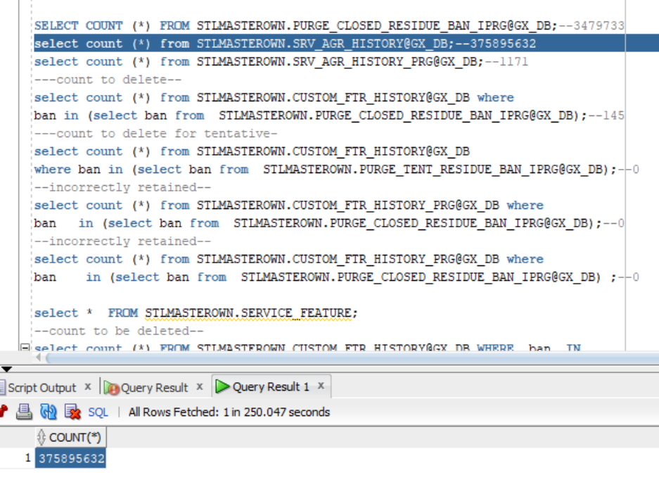

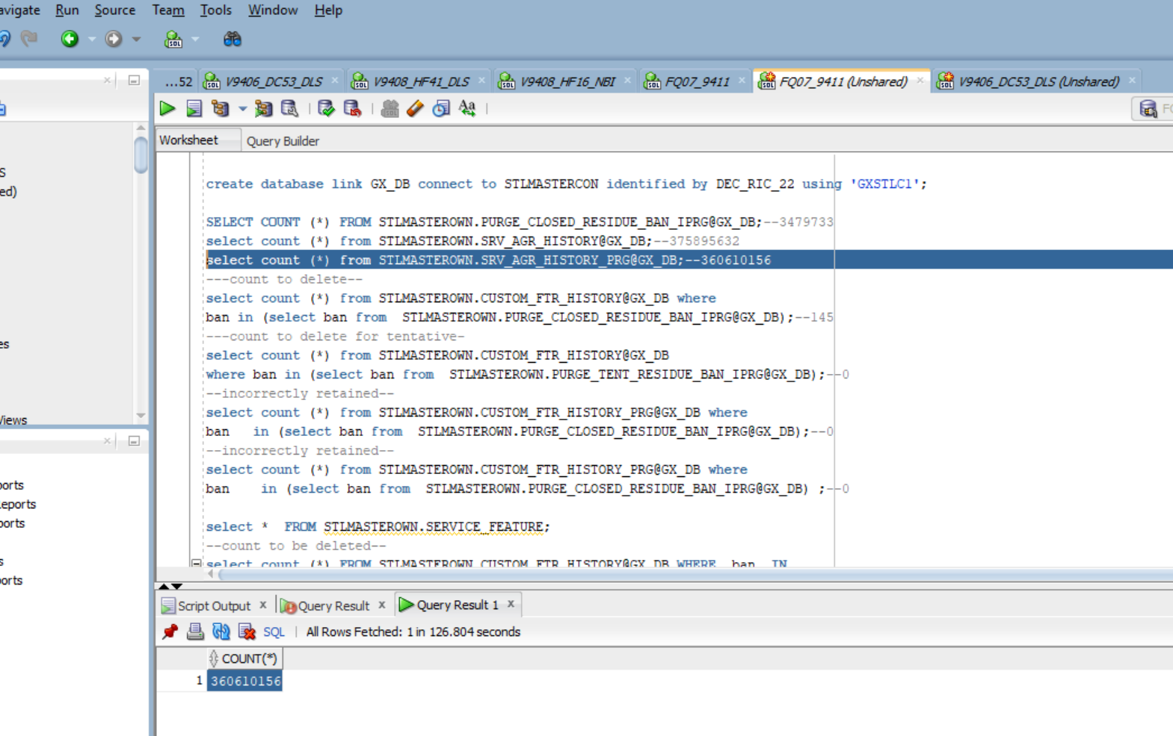

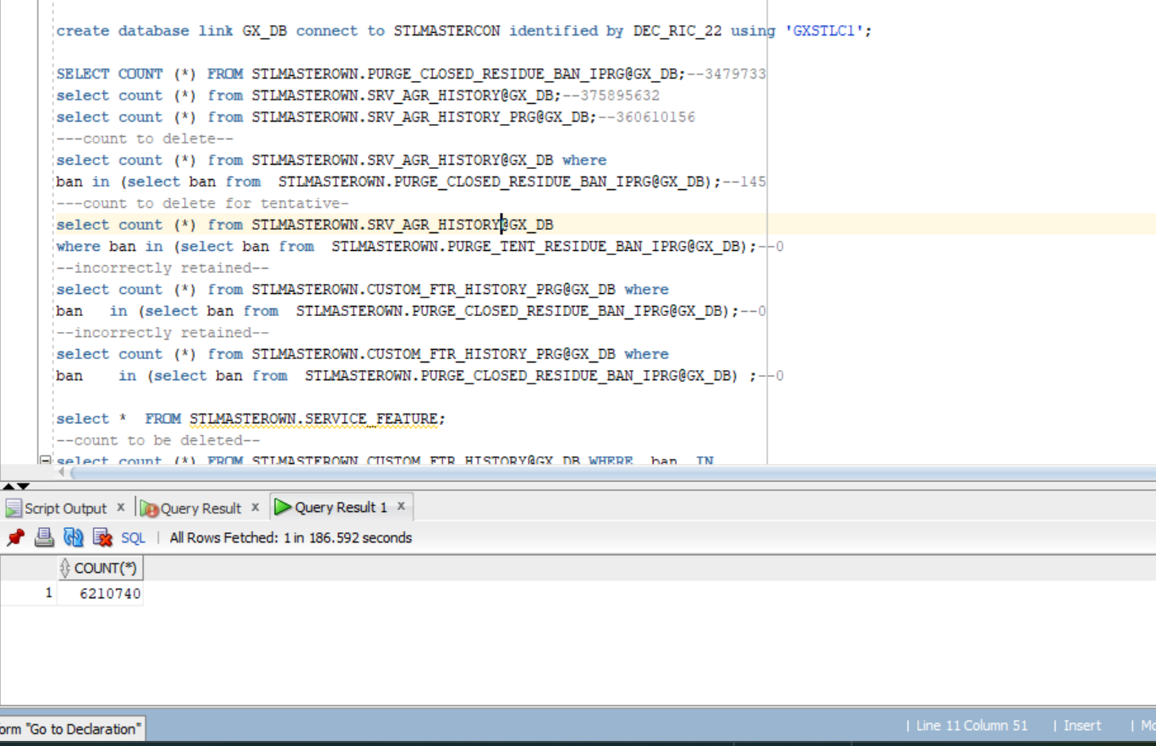

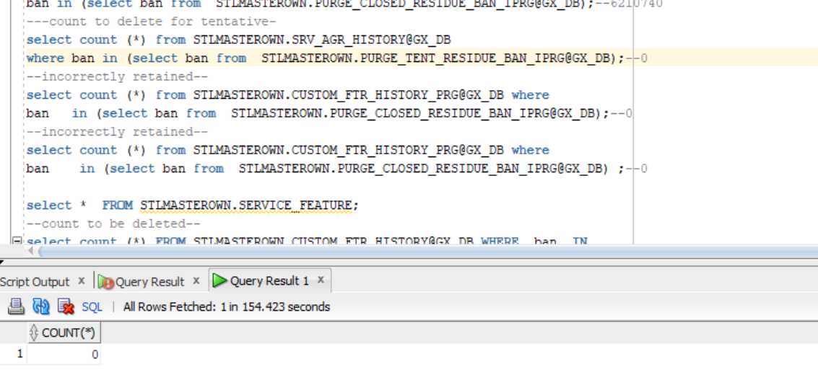

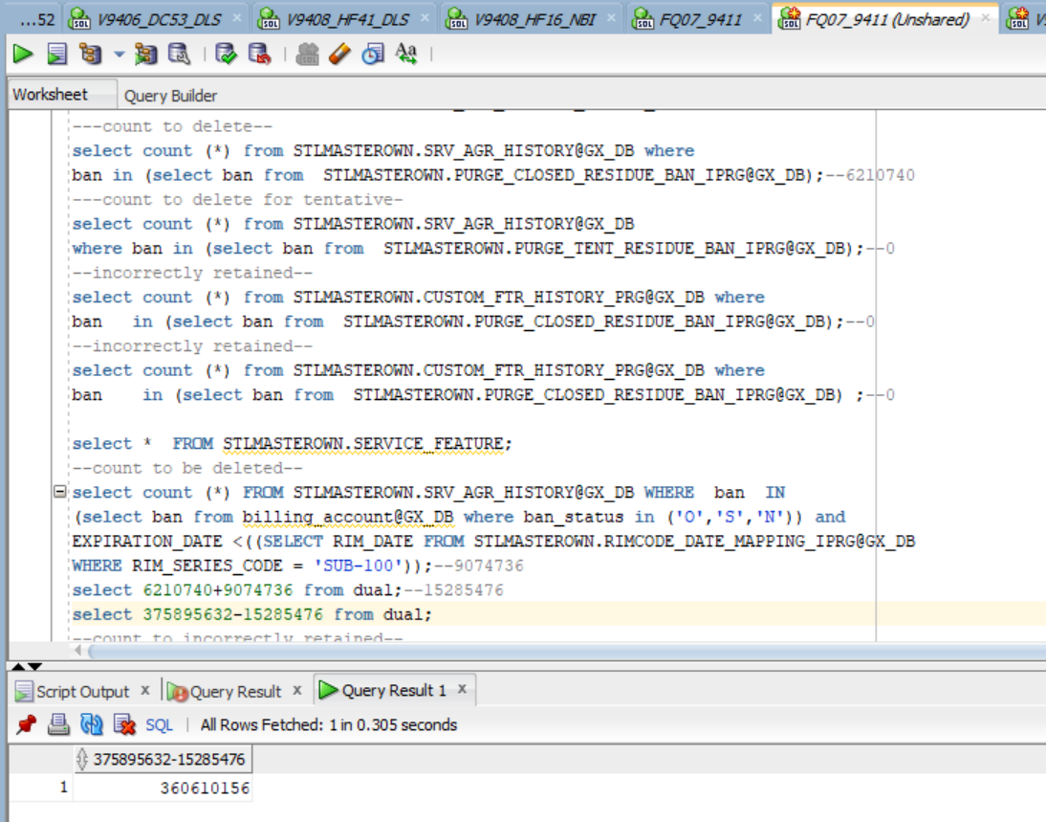

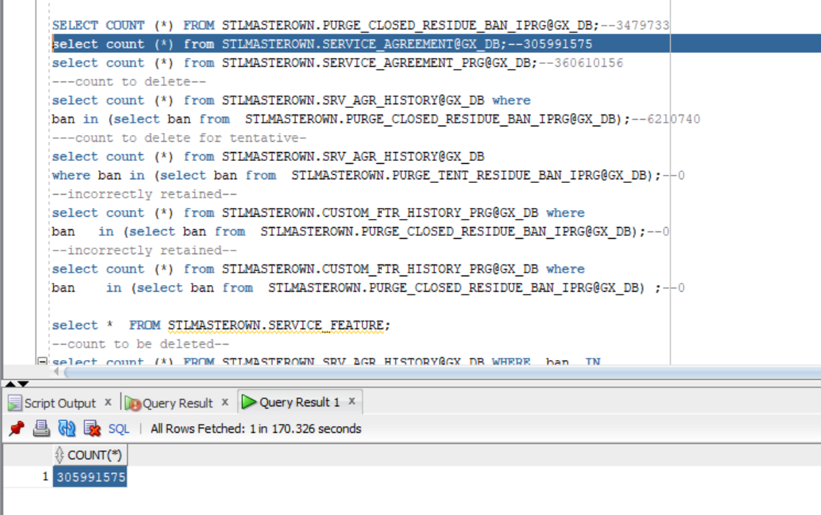

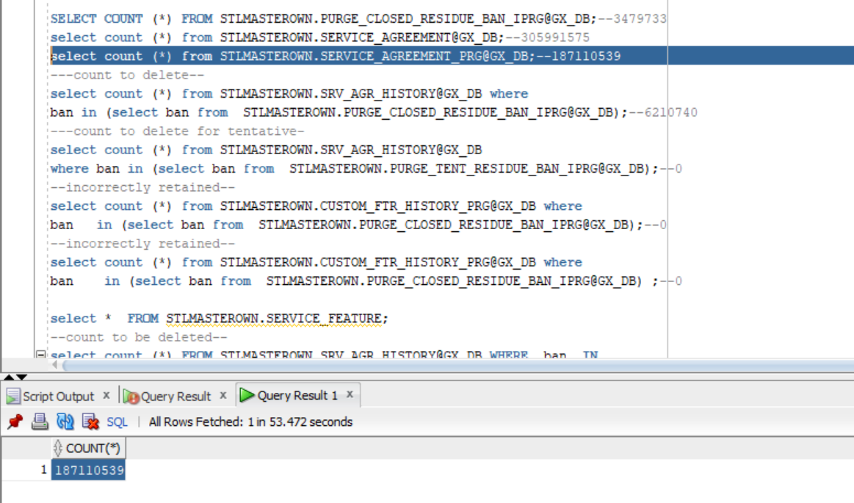

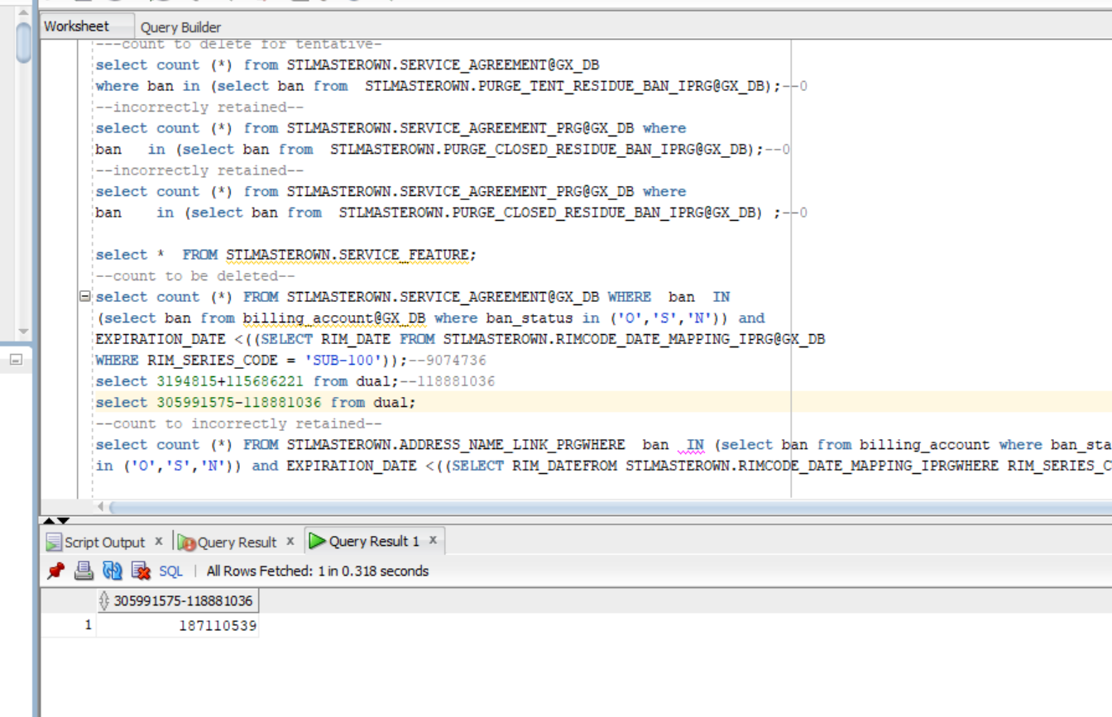

create database link GX_DB connect to STLMASTERCON identified by DEC_RIC_22 using 'GXSTLC1';

SELECT COUNT (*) FROM STLMASTEROWN.PURGE_CLOSED_RESIDUE_BAN_IPRG@GX_DB;--3479733

select count (*) from STLMASTEROWN.SERVICE_AGREEMENT@GX_DB;--305991575

select count (*) from STLMASTEROWN.SERVICE_AGREEMENT_PRG@GX_DB;--187110539

---count to delete--

select count (*) from STLMASTEROWN.SERVICE_AGREEMENT@GX_DB where

ban in (select ban from STLMASTEROWN.PURGE_CLOSED_RESIDUE_BAN_IPRG@GX_DB);--3194815

---count to delete for tentative-

select count (*) from STLMASTEROWN.SERVICE_AGREEMENT@GX_DB

where ban in (select ban from STLMASTEROWN.PURGE_TENT_RESIDUE_BAN_IPRG@GX_DB);--0

--incorrectly retained--

select count (*) from STLMASTEROWN.SERVICE_AGREEMENT_PRG@GX_DB where

ban in (select ban from STLMASTEROWN.PURGE_CLOSED_RESIDUE_BAN_IPRG@GX_DB);--0

--incorrectly retained--

select count (*) from STLMASTEROWN.SERVICE_AGREEMENT_PRG@GX_DB where

ban in (select ban from STLMASTEROWN.PURGE_CLOSED_RESIDUE_BAN_IPRG@GX_DB) ;--0

select * FROM STLMASTEROWN.SERVICE_FEATURE;

--count to be deleted--

select count (*) FROM STLMASTEROWN.SERVICE_AGREEMENT@GX_DB WHERE ban IN

(select ban from billing_account@GX_DB where ban_status in ('O','S','N')) and

EXPIRATION_DATE <((SELECT RIM_DATE FROM STLMASTEROWN.RIMCODE_DATE_MAPPING_IPRG@GX_DB

WHERE RIM_SERIES_CODE = 'SUB-100'));--9074736

select 3194815+115686221 from dual;--118881036

select 305991575-118881036 from dual;

--count to incorrectly retained--

select count (*) FROM STLMASTEROWN.ADDRESS_NAME_LINK_PRG WHERE ban IN (select ban from billing_account where ban_status

in ('O','S','N')) and EXPIRATION_DATE <((SELECT RIM_DATEFROM STLMASTEROWN.RIMCODE_DATE_MAPPING_IPRGWHERE RIM_SERIES_CODE = 'SUB-100'));

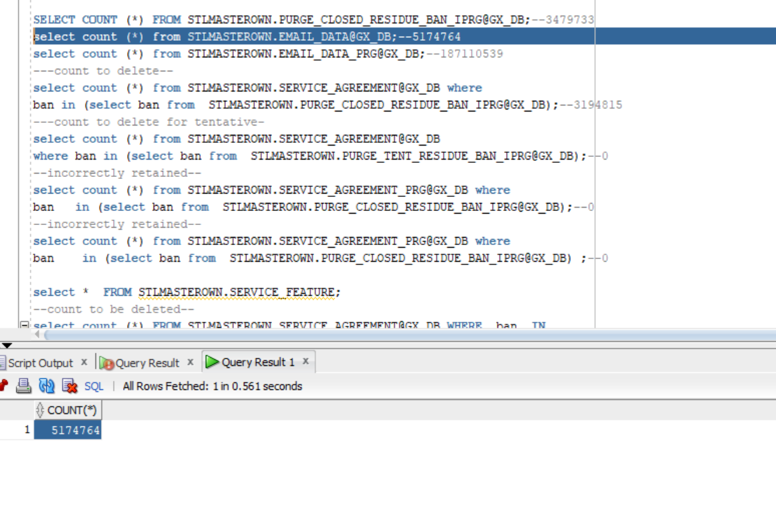

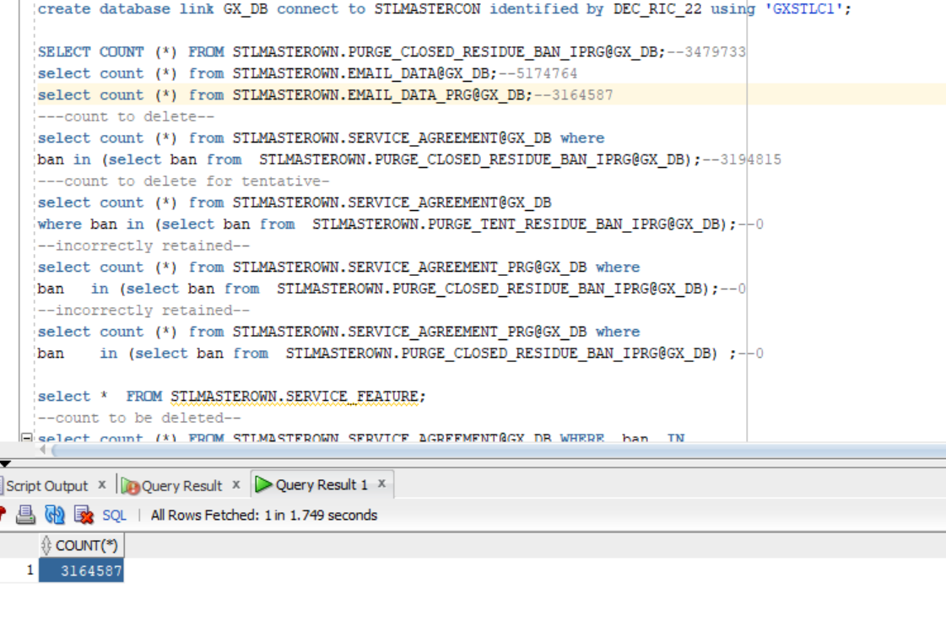

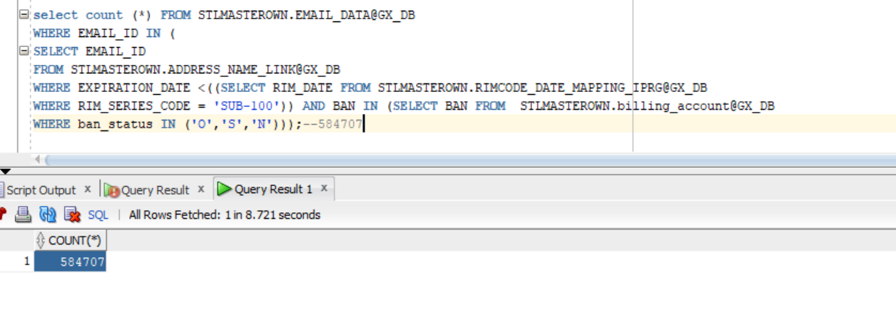

ADDRESS DATA

